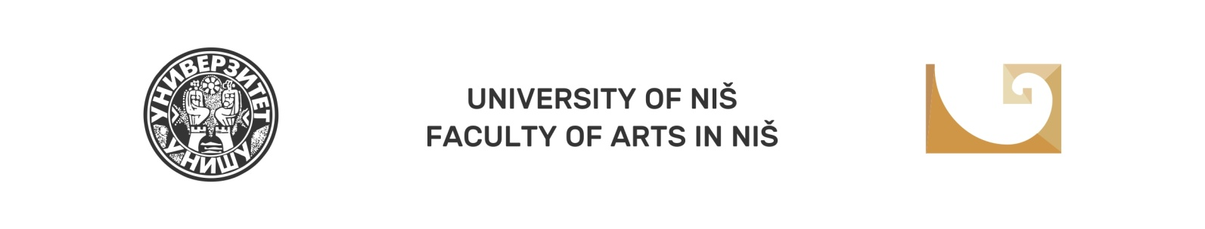

VII National Scientific Conference with International participation Balkan Art Forum 2019 (BARTF 2019) Niš

ART AND CULTURE TODAY:
METAPHOR, PERCEPTION AND SYMBOLISM

APPLICATION FORM

Name, middle letter and surname
Scientific title
Name and address of the institution you work at
E-mail address
Mobile phone
PAPER TOPIC
FIELD
TOPIC FRAMEWORK
Biography
(up to 150 words)

