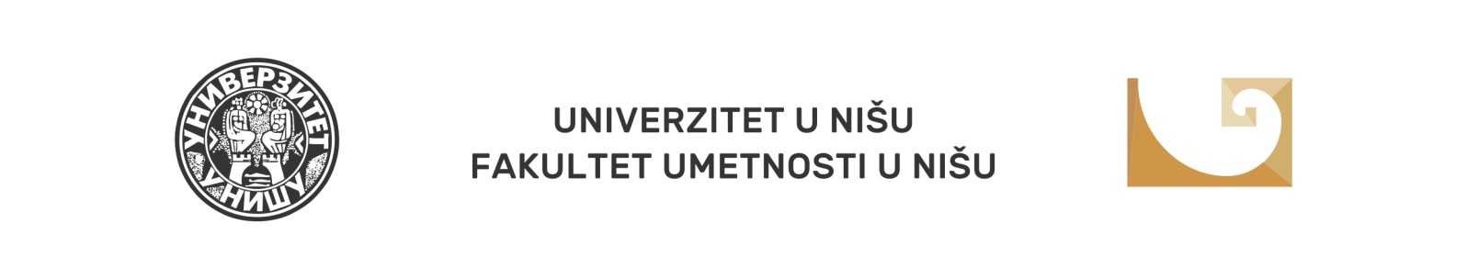
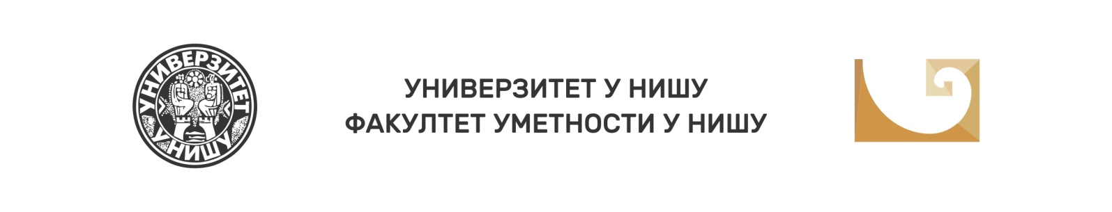

IX National Scientific Conference with International Participation Balkan Art Forum 2021 (BARTF 2021)

Niš, 8-9 October 2021

The Faculty of Arts of the University of Niš, in cooperation with the Branch of SASA (Serbian Arts and Science Academy) in Niš, organises the Ninth National Scientific Conference with International Participation, targeting the key topic Art and Culture Today: Harmony and Disharmony. As stated by the founding goals of the Conference, to continue the good tradition of problematising current phenomena and vital topics of art theory, turning the challenges of modernity into a creative challenge, the BARTF Organising Committee kindly invites all the experts willing to take an active role and join the Conference by presenting a paper, this year dedicated to the phenomena of harmony and disharmony and their all-pervading influence on creativity and culture.

The broad corpus of issues related to the principles of harmony and disharmony requires additional scientific research, theoretical observations, contemporary understandings, and fresh interpretations, especially from the perspective of challenges and crucial influences in the field of artistic creation, diffusion and reception of artworks and taste formation. Experts of various profiles are expected to examine aesthetic, psychological, pedagogical, communication, artistic and many other assigned roles of harmony and disharmony in their papers and discussions, paying special attention to their place and function in both traditional and contemporary culture and art.

Topic framework:

- Harmony and disharmony in the physical, mental, social, and spiritual life
- Harmony and disharmony: cosmos and chaos / accord and discord / balance and imbalance
- Harmony and disharmony: traditional and modern art / modern and postmodern art
- The place of harmony and disharmony in educational and cultural processes and changes
- Disharmony as an aesthetic principle / source of creativity / norm of originality
- Harmony in the context of inventiveness - an obstacle or an incentive
- Natural imperfection as a potential of artwork
- Regressive feature of harmony
- Idealisation of nature - harmony in disharmony
- The aesthetics of Theodore Adorno's music: disharmony, dissonance, atonality, ugliness
- Postmodernist re-traditionalization of art: reinstitution of the principle of harmony or suppression of critical and emancipatory potential
- Disharmony and subversion; harmony and conformism

Fields of submitting a paper:
- Arts sciences
- Culture
- Art
- The media
- Sociology
- Pedagogy
- Psychology
- Librarianship

FORUM PARTICIPATION FORMS:
- Oral presentations
- Video presentations
- Poster - sessions

PRESENTATION TIME: 15 minutes

OFFICIAL FORUM LANGUAGES: Serbian, English, Slavic languages.

DEADLINE FOR SUBMISSION OF PAPER TOPIC WITH ABSTRACT
(in official language and in English, up to 150 words and up to 5 keywords): 1 June 2021 at the e-mail address: bartf@artf.ni.ac.rs
It is obligatory to specify in the Application form the field and the topic framework for which you are applying.
The abstract template and the registration fee payment instructions can be downloaded from the Faculty of Arts website.

ABSTRACT ACCEPTANCE NOTIFICATION DEADLINE 20 June 2021

REGISTRATION FEE: 5.000,00 dinars or 40 Euros for participants from abroad, at the middle exchange rate of the National Bank of Serbia, on the day of payment. When paying the registration fee in foreign currency, the costs of banking fees are borne by the payer.
The registration fee includes a book of abstracts, a certificate of participation, and Conference Proceedings with peer-reviewed papers.

REGISTRATION FEE PAYMENT DEADLINE: 24 September 2021 or until the Conference opening

FULL PAPER SUBMISSION DEADLINE: 1 March 2022

For any further information, please contact the BARTF Organising Committee at the following e-mail address: bartf@artf.ni.ac.rs

Dean of the Faculty of Arts in Niš

Suzana Kostić, PhD

