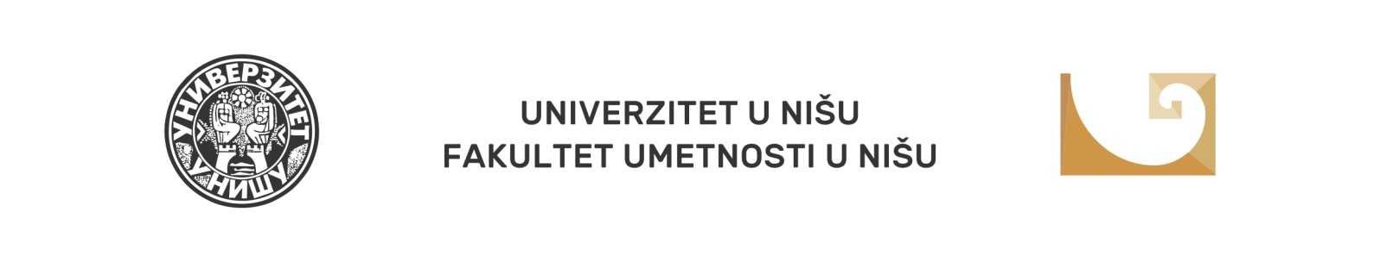
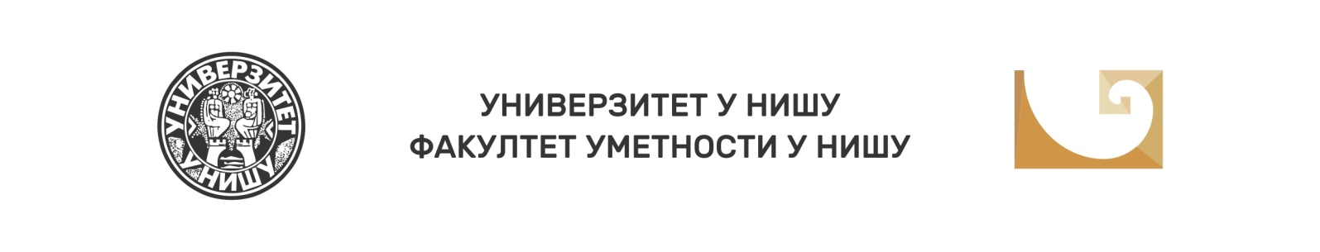

X National Scientific Conference with International Participation Balkan Art Forum 2022 (BARTF 2022)

Niš, 7-8 October 2022

The Faculty of Arts of the University of Niš, in cooperation with the Branch of SASA (Serbian Arts and Science Academy) in Niš, organises the jubilee tenth BALKAN ART FORUM (BARTF) - National Scientific Conference with International Participation, targeting the key topic Art and Culture Today: Interaction. The BARTF Organising Committee kindly invites all the interested experts willing to take an active role and join the Conference by presenting a paper.
This jubilee year is dedicated to the crucial impact of interaction as a multifaceted phenomenon in culture and artistic creativity, especially from the perspective of diffusion and reception of artworks and taste formation. Aware of the ubiquity and multidimensional aspect of interaction as a constitutive part of our world, taking into account its increased effect in the era of media expansion and intensive communication supported by advanced technologies, we recall the fundamental, naturally determined human insatiable need to connect with the surrounding world in all spheres.
In the light of reflection and problematisation of interaction in culture and art, we share with our colleagues from all social sciences, humanities and art only some of the many possible questions to consider: What is interactive art and is there passive art in the modern world? What are the dynamics of change in the triangle of the art world: creator - performer - consumer of the work of art? Is there direct interaction with the work of art in a media-cultivated environment? What is the impact of interaction when it comes to subjectivity in the reception of a work of art? How do you understand the transformations of the audience from passive to interactive?
The broad and complex issues about the nature and role and far-reaching influences of interaction in culture and art encompass numerous topics and call for problematisation, formulation and classification from several different perspectives to create the most fruitful framework for a comprehensive understanding of the problem.
Experts of various profiles are expected to examine aesthetic, psychological, pedagogical, communication, artistic, receptive and many other assigned roles of interaction in their papers and discussions, paying special attention to its place and function in both traditional and contemporary culture and art.

Topic framework:
- Interaction in the mental, social and spiritual life
- Interactive art: creative engagement of the audience; the breakthrough of the observer/listener into the world of image/sound
- Interaction in the context of aesthetic experience; interaction as an aesthetic principle
- Design and digital interaction
- A work of art in interaction with the world of media culture; a work of art as a microcosm of social interactions
- Interactive media and creativity
- The role of interaction in educational and cultural processes and changes
- Interaction and engagement of the work of art
- Interactive approaches to art education

Fields of submitting a paper:
- Arts sciences
- Culture
- Art
- The media
- Sociology
- Pedagogy
- Psychology
- Librarianship

FORUM PARTICIPATION FORMS:
- Oral presentations
- Video presentations
- Poster - sessions

PRESENTATION TIME: 15 minutes

OFFICIAL FORUM LANGUAGES: Serbian, English, Slavic languages.

DEADLINE FOR SUBMISSION OF PAPER TOPIC WITH ABSTRACT
(in official language and in English, up to 150 words and up to 5 keywords): 1 July 2022 at the e-mail address: bartf@artf.ni.ac.rs
It is obligatory to specify in the Application form the field and the topic framework for which you are applying.
The abstract template and the registration fee payment instructions can be downloaded from the Faculty of Arts website.

ABSTRACT ACCEPTANCE NOTIFICATION DEADLINE: 1 August 2022

REGISTRATION FEE: 5.000,00 dinars or 40 Euros for participants from abroad, at the middle exchange rate of the National Bank of Serbia, on the day of payment. When paying the registration fee in foreign currency, the costs of bank fees are borne by the payer.

The registration fee includes a book of abstracts, a certificate of participation, and Conference Proceedings with peer-reviewed papers.

REGISTRATION FEE PAYMENT DEADLINE: 4 October 2022

FULL PAPER SUBMISSION DEADLINE: 1 March 2023

For any further information, please contact the BARTF Organising Committee at the following e-mail address: bartf@artf.ni.ac.rs

Dean of the Faculty of Arts in Niš

prof. Milena Injac, DMA

X National Scientific Conference with International Participation Balkan Art Forum 2022

(BARTF 2022) Niš

ARTS AND CULTURE TODAY:
INTERACTION

APPLICATION FORM

Name, middle letter and surname
Scientific title
Name and address of the institution you work at
E-mail address
Mobile phone
PAPER TOPIC
FIELD
TOPIC FRAMEWORK
Biography
(up to 150 words)

