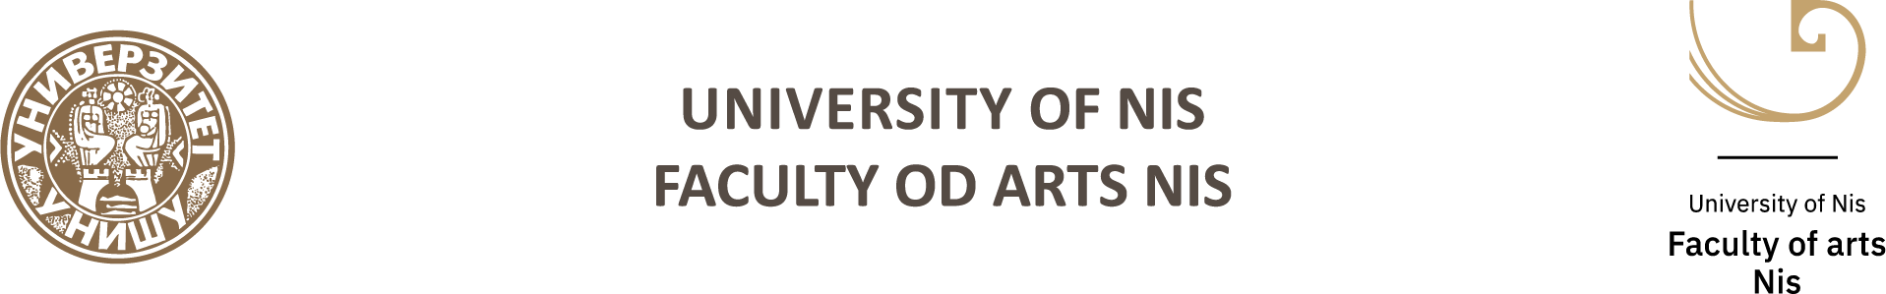

XII National Scientific Conference with International Participation

Balkan Art Forum 2026

(BARTF 2026) Niš

Niš, October 9‒10, 2026

ARTS AND CULTURE TODAY:
THE BODY AS MEDIUM: PERFORMATIVITY, IMAGE AND SOUND IN ARTISTIC AND RELIGIOUS CONTEXTS

APPLICATION FORM

Name and surname
Academic/Scientific rank
Organization name and address
E-mail address
Mobile phone
PAPER THEME
Abstract
(up to 250 words)
KEY WORDS

Biography
(up to 150 words)

